Chapter 7: Mapping the Historical Patterns of U.S. Foreign Policy

- Introduction
- Manifest Destiny
- An Overseas Empire
- The Business of Empire
- An “Informal” Empire
- The Cold War
- The War on Terror
- Cost of War
- The Landscape of U.S. Foreign Policy Today
- Summary

Introduction

How did the United States become the most powerful country in the world? How has the justification for U.S. intervention overseas changed overtime? What does it take to become a U.S. ally? Why does the United States fight wars around the world? How have the motivations for U.S. actions abroad evolved? How have they remained the same?

Throughout its history the United States has undergone multiple phases of foreign policy, yet patterns have emerged as to when and why the U.S. engages overseas. The United States, historically and presently, works to protect its economic, cultural and political interests abroad.

Manifest Destiny

The United States has always worked to justify its foreign policy, to frame itself as the “good guy” in a righteous battle between good and evil. The first manifestation of this logic was eventually titled “Manifest Destiny.”

Manifest Destiny explained U.S. expansion westward, by claiming that the seizing of Native and Mexican territory was legitimate because God willed it. In the 1600s Reverend Cotton Mather of Massachusetts explained, “Warfare against the Indians was a conflict between the devil and God.” On the side of God were the Anglo-American colonists who saw their military victory, and the death of Native Americans due to disease as divine proof that they, not the natives, were chosen to inhabit the entire United States. John Winthrop who led settlers to 17th century Massachusetts explained that, “God was making room for the settlers and hath hereby cleared our title to this place.” (Takaki) According to Anglo-Americans, God wanted the Natives gone. To these white colonizers, divine providence justified a war of extermination against native peoples to clear more of the American landmass for Christians whose families came from Europe.

From the founding of the United States well into the 20th century, many White U.S. citizens continued to believe that providence had preserved the land of “Others” for them. By the middle of the 19th century, this belief that a divine power had guaranteed all of the land between the Atlantic and Pacific Oceans for the United States developed into a deeply entrenched ideology, a story that white Americans told themselves about themselves, for over 200 years. In 1845, this ideology was coined by a journalist as Manifest Destiny.

While continuing to move West and pushing the Natives off their land, White U.S. nationals in the 1830s and 1840s also began to see Mexico as a threat to their ambition to extend U.S. borders.

Undocumented U.S. immigrants flooded into the Mexican province of “Tejas” before waging a war for independence from Mexico between 1835-1836. This conflict arose largely over the issue of slavery which Mexico had abolished and which these White U.S. settlers, many of whom were slave owners, wanted to preserve. U.S. citizens from across the United States rushed to join the fight against the Mexican army.

The independent nation of “Texas” emerged from this conflict, yet Anglo-Americans were not satisfied. Ascending President James K. Polk sought to acquire the rich ports of Mexico’s California province. After creating conditions to justify an invasion, President Polk sent in U.S. forces. In defeating Mexico, widespread atrocities were committed against Mexican civilians by U.S. forces. The behavior of U.S. troops led many immigrant Irish troops, fighting with the United States, to switch sides in the conflict and fight with their fellow Catholics in Mexico’s army.

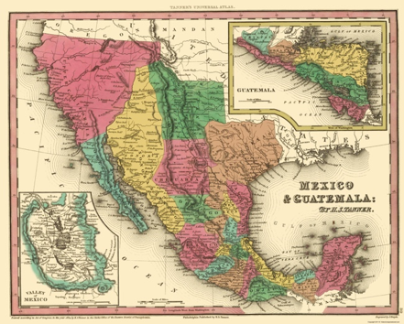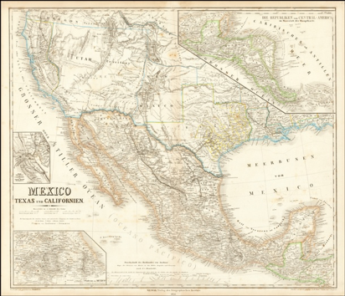
Mexico Before Texas Revolution (1835) Mexico After Treaty of Guadalupe-Hidalgo (1848)

In the Mexican American War (1846-1848), the United States, for the first time on a large scale, militarily expanded its territory through a war with another country. The Mexican American War was formally concluded by the Treaty of Guadalupe-Hidalgo. The treaty granted the United States the disputed Texas territory, as well as the soon to be states of New Mexico and California. In these territories lived 75,000-100,000 now Mexican Americans. Despite being declared U.S. citizens, for over a century, White U.S. citizens curbed the political, social and economic rights of Mexican Americans throughout the Southwest. The 150,000 Native Americans who lived in these new U.S. territories were slaughtered and brutalized. Within 12 years, the Native population of the area was reduced to 30,000 due to disease, expulsion and a campaign of genocide.
An Overseas Empire

The term Manifest Destiny disappeared from the American vernacular in the years after the Mexican American War, however, it was re-popularized in the 1890s by U.S. citizens looking to expand U.S. influence overseas.

By the 1890s, powerbrokers within the United States were searching for a justification for their occupation and colonization of the Caribbean and Pacific Islands. While the ideas that became dubbed Manifest Destiny would continue to be influential, in the years since the Mexican-American war, slavery in the U.S. had been abolished. African-Americans had been declared citizens and many Black citizens had been elected to represent their communities in state and federal government positions. Non-white populations could no longer be dismissed as sub-human; the stealing of their lands or their forced enslavement could no longer be justified merely for the profits of Whites. Therefore, a new logic was developed to justify the taking of lands and colonizing of people far, and near.

By the end of the 1800s American logic emphasized that the mission to secure U.S. control of new lands was the selfless desire to “modernize” non-white populations so they too could be “civilized.” The White Man’s Burden is a term deriving from a pro-imperialist poem by Rudyard Kipling, representing a paternalistic idea that to lift up and “civilize” people in Asia, Africa and Latin America, Europeans and White U.S. citizens would need to take control of those places. With this logic to justify U.S. imperialism, Hawaii was annexed by the United States in 1896. The United States wrested the Philippians, Puerto Rico, Guam, and Cuba from Spain in the Spanish American War in 1898. Haiti, the Dominican Republic, Nicaragua, Panama and Vera Cruz, Mexico were all occupied in the first decades of the 20th century. Like today, these interventions overseas upset many U.S. citizens, however, their objections were largely ignored as U.S. businesses prospered while the U.S. government increased its own influence in global affairs.

Justification for the War of 1898 or the Spanish American War was secured by circulating propaganda about the evils of Spain’s occupation of Cuba. Before the U.S. intervention in 1898, U.S. political cartoons depicted Cuba as a woman, generally a white woman, in need of rescuing. This trope of the “White woman in need of being rescued” will become part of the psychology and mythology of America. The United States quickly defeated Spain with support from Cuban forces who had been waging a revolution off and on over the previous 30 years. In the [ensuing] peace treaty the United States secured Cuba, Puerto Rico, the Philippians and Guam from Spain. (Pérez, Cuba in the American Imagination, 77-79)

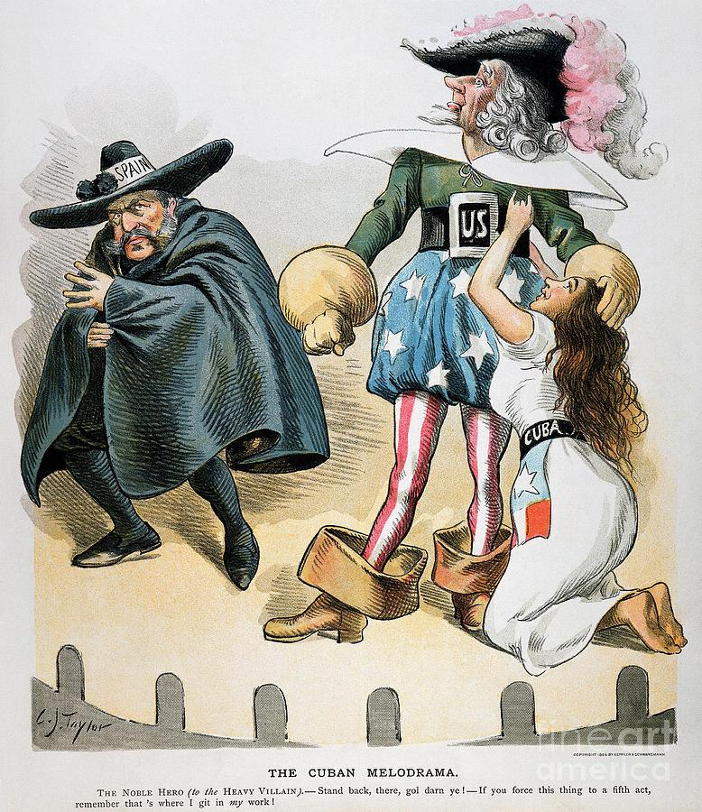

As was the case in the Spanish American War, the need to save the “virtue” of white women often justified violence. The supposed desire to “avenge” white women time and again justified the lynching of Black men in the U.S. South. More recently the rescuing of Afghani women from the Taliban helped form the logic for the U.S. occupation of Afghanistan that began in 2001. In all of these examples, “Femonationalism,” or “the practice of holding up the plight of women to justify racist or xenophobic ideas about, and acts of violence against another group, society or nation,” has been used to influence people to embrace war to “rescue” women.

After the United States won the Spanish-American War, the image of Cuba, Puerto Rico, and the Philippians changed in the U.S. Press. In political cartoons Cubans, Puerto Ricans and Filipinos were now displayed as “children,” often Black children as were the Dominicans and Haitian during their periods of U.S. Occupation. This was a fate also suffered by other nations that the United States considered under its sphere of influence. By portraying these peoples as kids, the U.S. press was justifying U.S. control.

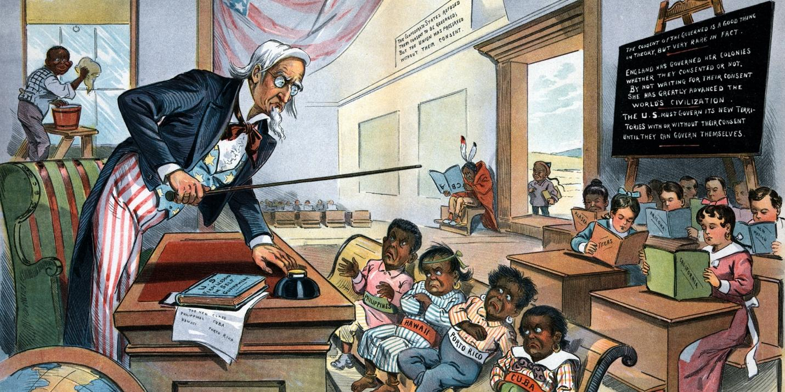
Assignment: Imagine that you open your local paper in 1900 and see this political cartoon. In a paragraph explain the how images like this cartoon work to justify the U.S. occupation of Cuba, Puerto Rico, Hawaii and the Philippines?

The Business of Empire

The occupations and newfound influence of the United States throughout the world proved profitable for U.S. businesses. U.S. companies were able exploit their connections with U.S. officials, often dictating policy in U.S. occupied lands. From the Caribbean to the Pacific, U.S. dollars secured contracts to build national railroads or cultivate farmland. Corporations like the United Fruit Company and National City Bank of New York held enormous sway over U.S. decision making in these occupied territories.

The U.S. government also directly benefited from these new territories as they acquired new military bases, laborers and soldiers without having to provide these peoples with equal rights. For instance, Puerto Ricans were made citizens of the United States in 1917 with the passage of the Jones Act, which made them eligible to be drafted into the U.S. Army during World War One. However, despite widespread service in the armed forces, those citizens who live in Puerto Rico, Guam, the U.S. Virgin Islands, and the Northern Mariana Islands—territories still held by the United States today—were and still are systematically denied voting representation in Congress and are excluded from participating in U.S. Presidential Elections. (John Oliver, “Puerto Rico”) Without the vote, these U.S. territories often experience disadvantageous economic policies and inadequate responses from the Federal Government to natural disasters as when Hurricane Maria struck Puerto Rico in 2017. In 2018 Puerto Rico’s poverty rate stood at 43%. (Hurricane Maria)

https://www.youtube.com/watch?v=Tt-mpuR_QHQ

Assignment: After reading “The Business of Empire” and watching Puerto Rico write a paragraph making an argument for how the U.S. relationship with the islands and people of Guam, Puerto Rico, the U.S. Virgin Islands, and the Northern Mariana Islands should change or stay the same.

An “Informal” Empire

By the twentieth century, the U.S. government and its corporations often sought to extract resources without the formal colonization of foreign peoples. The United States was no longer primarily motivated by land acquisition, as had been the case in the conflicts against Native Americans, Mexicans, Hawaiians, and Spaniards. U.S. powerbrokers remained dependent on the backing of the U.S. military in enforcing U.S. empire; however, most U.S. occupations that began after 1900 were temporary.

Still, a return to local rule did not mean a return to national sovereignty. The United States ensured that formerly occupied territories, even upon the exit of U.S. troops, would remain profitable for, and beholden to U.S. businesses. In Cuba, before the United States left the island in 1902, Cubans were forced to insert the Platt Amendment into their constitution specifying that the United States could intervene in the internal affairs of the island. While forcing this Amendment into the Cuban constitution horrified the Cuban population, it was not a right the United States would shy away from asserting. (Finesurrey, 2018) Platt forced Cuban policymakers to prioritize U.S. economic, political and cultural interests, while severely constraining the effectiveness of Cuban strategies to address Cuban poverty, health care, infrastructure and education. (Finesurrey, 2020)

Dollar Diplomacy in Haiti
In December 1914, New York Financier Roger L. Farnham helped convince Secretary of State Williams Jennings Bryan to send U.S. Marines into Haiti’s Banque Nationale. Farnham made off with the modern equivalent of $2.66 million dollars, which he deposited in National City Bank of New York where he served as Vice President. (Leonard) Predictably, after this theft, Haiti defaulted on its debt payments, which became part of the justification for the U.S. occupation of the nation that lasted from 1915-1934.
The island had been independent since the ousting of the French in a slave revolt in 1804. Haiti was now occupied by the United States. U.S. officials took control of Haiti’s government and created a U.S. trained and managed police force to protect U.S. investments. During the U.S. occupation Haitians built roads and rail under U.S. military or corporate supervision. The railroad was designed to connect ports to coal deposits and agricultural regions deemed by U.S. businessmen to have potential for commercial profit. (Senate Testimony, 1921) To be clear, these tracks were not designed to connect the Haitian people, but laid to capitalize on the extraction of Haitian resources. The nation’s transportation network was built by Haitians paid literally nothing, conscripted to work for the U.S. army engineers. On at least one occasion Haitians conscripted to infrastructure projects were shot for attempting to escape this forced labor. (Senate Testimony, 1921)

The Cold War (1945-1991)
https://www.youtube.com/watch?v=9C72ISMF_D0

Allies during World War II, the United States and the Soviet Union soon after became enemies competing for influence around the globe. The Cold War between the United States and the Soviet Union was directed throughout the world as both nations tried to exert their influence. After the Soviet Union developed an atomic bomb in 1949, both the USSR and the U.S. became hesitant to attack each other directly. By the 1960s the U.S. and USSR had so many rockets pointed at each other, an attack by either nation would mean Mutually Assured Destruction (MAD). Rather than obliterating themselves with a direct attack, each nation cultivated a network of alliances through humanitarian or military aid, shared interests, and often coercion. (American Government and Politics in the Information Age)

The United States and the USSR dodged bilateral conflict with one another. However, proxy wars were fought in Europe, Latin America, Africa and Asia between US-and-USSR-backed political movements. The CIA, at the directive of the President of the United States, often found itself working on behalf of U.S. business interests to prop up anti-communist and pro-U.S. business dictators. Without the legitimacy garnered by free elections, these dictators were, and are, often dependent on U.S. arms to keep power despite ruling over a populace that largely does not support them. U.S. arms and U.S. training of foreign security forces have often led to violent undemocratic governments that continue to receive U.S. “support” because they support U.S. interests.

During the Cold War countries around the world learned to prioritize U.S. or Soviet interests, often at the expense of their own people’s priorities. After numerous military and diplomatic interventions, many world leaders became aware that their ability to govern depended on the support of one of these two governments as opposed to the support of their citizens.

In the midst of the Cold War, the enemy declared by the U.S. government was Communism. If a world leader was anti-Communist and pro-U.S., regardless of their treatment of their own citizens and/or democratic legitimacy, they could likely count on the support of the United States government. (American Government and Politics in the Information Age) Militarily weaker nations secured U.S. loyalty by establishing a pro-U.S. business government. Those leaders not loyal to U.S. interests were often replaced with those who were through a combination of covert, diplomatic or military actions taken by the U.S. government. (Finesurrey, 2018) U.S. corporations, policy makers, and intelligence agencies all saw themselves as allies in the fight to maintain U.S. economic and political influence worldwide.

Assignment: In a paragraph, with evidence from “An Overseas Empire,” “The Business of Empire,” “An ‘Informal’ Empire,” and “The Cold War” explain why people living in places dominated by a foreign power might become resentful of that power?

War in East Asia

https://www.youtube.com/watch?v=Y2IcmLkuhG0

While the CIA intervened in Latin American, Middle Eastern, African, and European nations, the first large deployment of U.S. troops into a warzone to contain the influence of the Soviet Union took place in South-East Asia. From China, to Korea, followed by Vietnam, then Cambodia and Laos, U.S. arms preceded U.S. advisors, who often preceded U.S. troops and U.S. bombs.

The Korean War
https://www.youtube.com/watch?v=-X7nbwFxGRU
The United States intervened in Korea to stop the spread of Communism, coming to the aid of a violent repressive government in South Korea. Intervening on behalf of the nearly defeated South, in a radical change in precedent, President Harry S. Truman justified entering the conflict through a United Nations Security Council resolution as opposed to a declaration of war from Congress. The Korean War (1950-1953) was a humanitarian disaster that cost the lives of three-million Koreans and escalated a conflict between North and South Korea that continues to this day.

In 1950s and 1960s the United States supported a number of the anti-communist dictators and generals in South Vietnam, while the Communist Ho Chi Mihn was the undisputed leader of North Vietnam. Since attempting to secure Vietnamese rule of Vietnam from President Woodrow Wilson in 1919, Ho Chi Mihn continued to push for self-rule by founding the Vietnamese Communist Party in 1930, which demanded independence from France. During the WWII Japanese occupation of Vietnam, Ho Chi Mihn founded the “Viet Minh” to fight the Japanese invaders. Upon the withdrawal of the Japanese, Ho Chi Mihn declared Vietnamese Independence. The French, encouraged by the United States after the end of World War II, refused to recognize Vietnam’s independence and recolonized the nation.

Ho Chi Minh led the Vietnamese to successfully expel the French from Vietnam in 1954 after the battle of Dien Bien Phu. An election was to be held in 1960 to determine who would lead the nation going forward. When it became clear that Ho Chi Minh and the Communists were poised for a victory, the U.S. government under President Eisenhower pushed to cancel the elections. By cutting off a democratic future for Vietnam, policymakers in the United States and South Vietnam began a conflict that would not end until 1975.

The United States became increasingly involved throughout the 1950s and 1960s in a process called Mission Creep. Early on the United States government supported the leaders in the anti-communist South with military equipment. Soon this gave way to the sending of U.S. military advisors. By the early 1960s, U.S. combat troops were dying alongside South Vietnamese forces. After the Gulf of Tonkin Resolution in 1964, the United States publicly embraced its role as the main opposition to Ho Chi Minh’s leadership over a united Vietnam.

By the mid-to-late 1960s media coverage of the war was becoming more critical. The American public was beginning to feel betrayed and lied to by its government. By late March, approval of President Johnson’s “handling of the situation in Vietnam” had dropped to 26 percent and disapproval swelled to 63 percent (Gallup Organization, 1992). On March 31, 1968, the president announced he would not run for reelection and that U.S. bombing of North Vietnam would be restricted. (American Government and Politics in the Information Age)

With the assassination of Robert F. Kennedy and the failed nomination of anti-war candidate Eugene McCarthy, Johnson’s Vice President Hubert Humphrey became the Democratic nominee for President in 1968. His support of President Johnson’s efforts in Vietnam aided the candidacy of Humphrey’s Republican opponent Richard Nixon who promised he had a secret plan to end the war in 1968.

President Nixon won the election of 1968 and announced he was spreading the war to Cambodia, which provoked uproar throughout the nation. College campuses were shut down because of massive protests, and, on May 4 National Guardsmen who had been brought in to put down the student protests at Kent State University, shot and killed four undergraduates. Less than two weeks later at Jackson State College, a Historically Black institution, a law student and a high schooler were gunned down by law enforcement officers.

By early 1971, just 28% of the nation supported the war in Vietnam. With the publication of the Pentagon Papers in June 1971, it became known to all that as far back as the mid-1960s it was clear to U.S. policymakers that the war was unwinnable. The inability to come up with an exit strategy destabilized the region, while undermining Americans’ trust in their government. (Vietnam: The Downward Spiral) By the time the war finally ended, 55,000 U.S. troops had lost their lives in Vietnam and $150 billion was spent on the war effort. Countless veterans returned home traumatized by the experience and were met with a cold reception by an angry nation.

The War on Terror

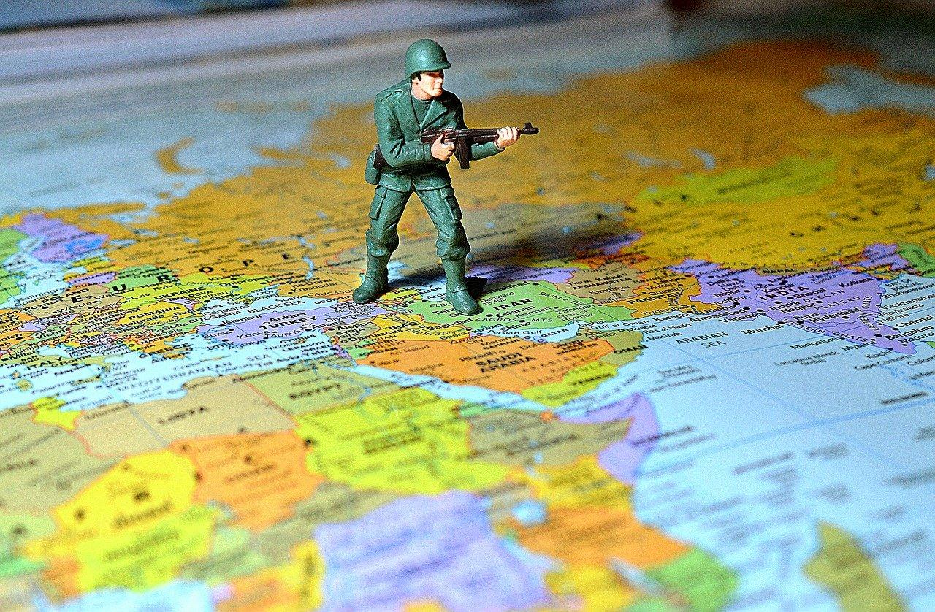

On September 11, 2001 Al Qaeda terrorists armed with simple box cutters took over four passenger planes, transforming them into lethal weapons. They flew two of the jets into the Twin Towers of the World Trade Center in New York City, killing 2,823 people and injuring many others. They flew the third plane into the Pentagon, causing more casualties and serious damage to the building. Passengers prevented the terrorists from flying the fourth plane to Washington, D.C., and that plane crashed in the Pennsylvania countryside. Shown throughout the world, the horrifying shots of the planes flying into the Twin Towers are enduring images of a spectacular attack on the symbols of U.S. economic might. They graphically exposed the ability of terrorists from abroad to attack on U.S. soil. They shocked American politicians, media members and civilians into a patriotic furor that would lead to the longest conflict in U.S. history and a “War on Terror” that continues to this day.

https://www.youtube.com/watch?v=orawG7vt68o

Osama Bin Ladin explained that he saw the United States as an imperialist nation that held a lot of power in the Arabian Peninsula in pursuit of Saudi Arabian oil. As a Saudi himself, Bin Ladin classified U.S. influence in his home nation as an insult to Arab sovereignty and the Muslim faith. Further, Bin Ladin blamed U.S. support of Israel for the death of countless Palestinians. In response, Bin Ladin organized the 9/11 attacks that he hoped would strike at the heart of U.S. economic, military and political power.

In the months after the attacks, as the nation healed, President George W. Bush saw his approval rise to 73%. Scared of another attack, U.S. citizens rallied behind President Bush who promised to keep Americans safe. By 2002 President Bush felt secure enough to advance his doctrine of preemptive war, where the use of force is justified if an imminent threat is perceived. The President and his team spoke pointedly about the “Weapons of Mass Destruction,” being constructed in Iraq that threatened U.S. and global security. (Kellner, 2004)

The Bush Administration could depend on the news media to support the march towards war in Iraq. Connie Shultz of the Nation explains, “In 2003, virtually every newspaper endorsed the war, and journalists reported as fact the false claim that Iraq had weapons of mass destruction. This was an unchallenged lie pitched by then–Secretary of State Colin Powell, who has since professed remorse. Many journalists later expressed regret for falling for it.” (Shultz, 2020) Before the war, the media uncritically promoted the administration's propaganda campaign against the Iraqi government, which later proved to be untrue (Massing, 2004; New York Times, 2004; the Washington Post, 2004; Massing, 2004; Kuypers, 2004). The television networks rarely covered the mass movements organizing throughout the United States against the war (Hayes & Guardino, 2010).

The New York Times in particular supported the administration’s rationale for going to war with Iraq by accepting as truth the information provided by the Bush Administration and taking Iraqi exiles’ claims at face value, displaying them on the front page as verified fact. The Times gave glowing coverage to Secretary of State Colin Powell’s monumental United Nations speech and presentation in February 2003, which supposedly documented Iraq’s weapons of mass destruction. The Times undermined the credibility of Iraqi government denials about building weapons of mass destruction by following them with challenges from U.S. officials, and discredited U.S. and foreign sources critical of the administration’s argument. (American Government and Politics in the Information Age)

Stories challenging the Bush Administration’s case for war were downplayed. Journalist James Risen wrote extensively about the falsehoods told by the Bush Administration in the lead up to the War in Iraq, only to be censored by his employer, The New York Times. Risen’s article “C.I.A. Aides Feel Pressure in Preparing Iraqi Reports,” documented persuasively that intelligence memos were being altered due to political concerns. The article was completed several days prior to the invasion, but not printed until three days after the start of the war, and relegated to page B10 (Okrent, 2004). The Times coverage gave credibility to the administration’s arguments to go to war. Moreover, as the paper of record, many news organizations including CNN and National Public Radio, followed the Times’ lead and the drumbeat to war effort. (American Government and Politics in the Information Age)

The lack of vigorous challenges by leaders of the Democratic Party to the Bush administration in the run-up to the war left little pressure on the news media to investigate the claims of the Bush administration. While many in congress, including Bernie Sanders, Nancy Pelosi, Ted Kennedy, and Barbara Lee voted against the conflict, much of the Democratic leadership including John Kerry, Joe Biden, Hillary Clinton and Chuck Schumer sided with the GOP and the Bush Administration to authorize the use of force in Iraq. (Vote Count) The Times’ coverage contributed to the Democrats’ complicity. Perhaps, if the Times and other media outlets had published more critical stories, some Democrats could have found the courage to challenge the weapons of mass destruction claim and attack the war policy.

As the war began, much of the mainstream media reproduced the U.S. government’s, and the U.S. military’s priorities to frame their coverage of the conflict. Prominent news stories provided by the Bush administration became highly publicized before turning out to be factually inaccurate. The famous rescue of Private Jessica Lynch and the death of Corporal Pat Tillman are most notable among these. Other news stories were manipulated to support pro-U.S. perspectives. For instance, the pulling down of Saddam Hussain’s statue was reported as a popular uprising culminating in the destruction of a hated tyrant’s statue. In fact, the statue was removed by a small group of Iraqis alongside journalists and U.S. Marines. When troubling accounts of torture and abuse by U.S. troops, including at Abu Ghraib prison began to emerge, the media turned its attention to tales of U.S. military heroism and images that supported the narrative that the United States was a force for good in Iraq.

Media coverage of the war began to change on the eve of the 2004 Election with Democrats running against the conflict. However, the party nominated John Kerry, who initially supported giving the Bush Administration the authorization to go to war, over Howard Dean who had voted against the conflict. The Bush campaign successfully framed Kerry as inconsistent and won reelection. President Donald Trump would be able to do the same thing against Democratic nominee Hilary Clinton in 2016 election, helping him secure victory, in part, as the anti-War candidate. As had been the case for Hubert Humphry in 1968, John Kerry in 2004 and, most recently for Hillary Clinton, initial support for an unpopular war that began under false pretenses helped undermine their ultimately unsuccessful presidential campaigns.

Assignment: After reading “An Overseas Empire” and “The War on Terror” write a paragraph explaining the role does the media has in the way the United States interacts with the rest of the world. Use evidence from the chapter to make your argument.

Cost of War

https://www.youtube.com/watch?v=aVr0MSEW2SU&feature=youtu.be

The War on Terror has left thousands of U.S. soldiers in the Middle East dead and tens of thousands dealing with injuries and Post-Traumatic Stress Disorder (PTSD). An estimated one million Middle Eastern civilians have been killed directly or indirectly by the turmoil since the United States destabilized the Middle East by overthrowing the governments of Afghanistan and Iraq. As of September 2020, least 37 million refugees have fled their homes due the instability sparked by the War on Terror. (Ismay) Most have sought refugee status in North America, Europe and Australia. The United States government has agreed to take an extremely small percentage of Middle Eastern refugees. (World Economic Forum)

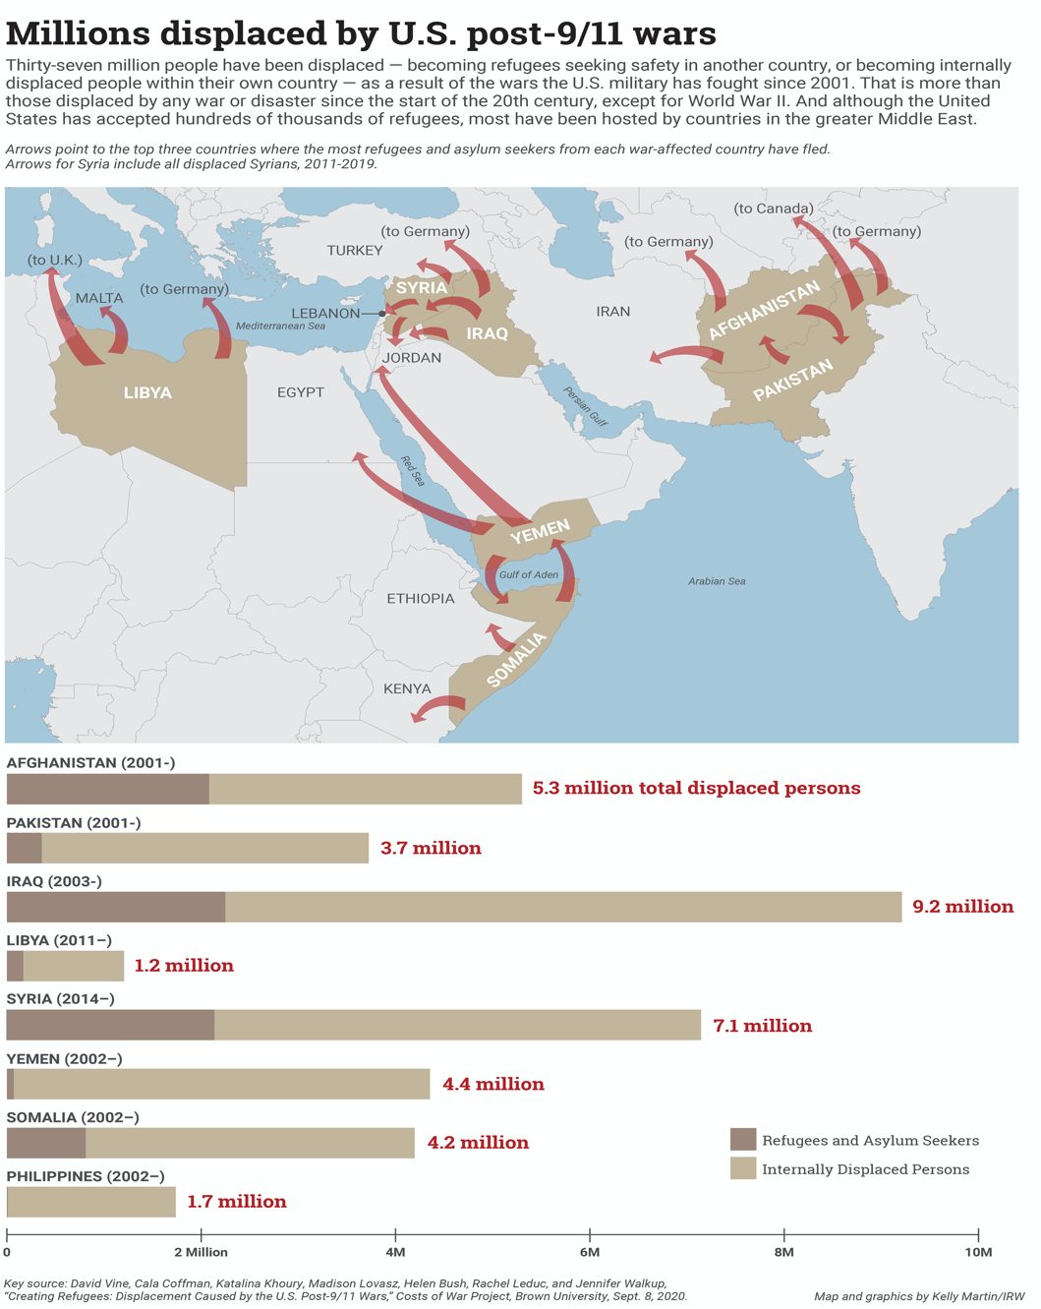

Assignment: Using evidence from the chapter, in a paragraph explain how you would change how U.S. foreign is funded and enacted.

The Landscape of U.S. Foreign Policy Today

While Presidents Barack Obama and Donald Trump have altered U.S. foreign policy towards particular nations, the main aims of U.S. foreign policy across history remain the same. U.S. frustration with two decades of war in the Middle East no doubt informed the decision making of the Obama and Trump administrations, as it now informs the Biden government. The nation-building campaigns of President George W. Bush failed. The nations that President Bush attempted to build in Iraq, Afghanistan and elsewhere remain unstable, and very expensive to U.S. taxpayers. While the Trump and Obama administrations have sought to curb U.S. troop deployment in warzones, both were extremely active in bombing “terrorist targets” in Middle Eastern and North African nations, often with unmanned predatory drones.

President Obama pursued an uneven foreign policy based on U.S. economic and political interests. Obama shifted the United States’ hardline stance against Cuba, Vietnam and Iran, and criticized the Israeli government in ways unprecedented in recent history. However, the Obama administration also recognized governments that overthrew democratic administrations in Honduras and Egypt. The Arab Spring, which seemed as if it would bring democracy to North Africa and the Middle East, was initially encouraged by the Obama administration. Since 2011, these popular uprisings across the region have resulted in widespread violence and instability.

Libyan Intervention
In March 2011, President Obama ventured into uncharted territory by intervening militarily in Libya. He said his purpose was humanitarian: to prevent the dictator Muammar Gaddafi from massacring the Libyans rebelling against his regime. The intervention, involved missile strikes against Gaddafi’s forces. Its ultimate intention was regime change—that is, to end Gaddafi’s rule. While Gaddafi would be brutally murdered during the uprising, it is difficult to argue that the nation of Libya is better off since his departure. Since 2011, Libya has been involved in a Civil War. The chaos that persists to this day has allowed the reemergence slavery in Libya.
President Trump has sought to decrease tensions with North Korea, while reigniting them with Iran and Cuba. He has continued U.S. support of Saudi Arabia, over the objections of Congress, which is helping to destabilize the Middle East by sponsoring a war in Yemen as it vies for regional supremacy with Israel, Turkey and Iran. Meanwhile, President Trump's attempts at creating peace between Israel and Palestinians, an effort led by his son-in-law Jared Kushner, has been widely panned as a one-sided effort that would indefinitely perpetuate the Israeli Occupation over Palestinians.
While the long-term consequences of both administrations’ foreign policies are difficult to analyze right now, U.S. decision making remains largely based on the resources and strategic significance of any given nation. The Kurds have been abandoned by the Trump administration, while famine and civil war in Sudan were largely ignored by the Obama government. The reason? Intervention in those crises by the United States offered little value to U.S. economic and political interests. While President Biden seems poised to improve relations with Western European nations that often clashed with President Trump and take a firmer stance against Russian President Vladimir Putin, U.S. policy towards most of the world will remain largely unchanged. The United States, guided most strongly by the principle (and practice) of self-interest, will remain extremely active in funding, arming and participating in conflicts worldwide.

Summary

Even before the United States was founded as a country, the idea that Europeans were entitled to the territory that would eventually become the United States by divine right shaped relations with Native Americans who were pushed from their homes to make way for white settlers. The idea that Native populations, and later Mexicans, should be supplanted by Whites was considered “God’s will” by many.

By the end of the 19th century, the logic of U.S. expansion began to change. To justify an overseas empire the U.S. employed the racist and imperialistic language of the “White Man’s Burden.” Framing U.S. influence as benevolent in political cartoons and official government discourses, the United States pursued self-serving military, social and economic goals throughout the Caribbean Basin and the Pacific Ocean.

In the late 19th Century, and throughout the 20th Century, the United States expanded its influence to other parts of the world, through its businesses, threats of force from the CIA and the U.S. military, actual wars, U.S. media, occupations and sometimes all of the above. As the United States emerged as one of the two superpowers after World War II loyalty from other nations was demanded by both the United States and the USSR. Yet the peoples across the globe revolted against these demands drawing U.S. troops into conflict zones in Asia, Africa and Latin America

After the collapse of the Soviet Union in 1991, the United States was the only remaining superpower on the globe. Expanding its economic reach further than ever before was often met with hostility from people in other countries who wanted to control their own nations economic, military and political affairs. On September 11, 2001 the United States was attacked by Osama Bin Ladin and Al Qaeda who demanded the United States withdraw from the Middle East and stop its support of Israel. Instead, the United States invaded Afghanistan, worked with the U.S. media to justify the invasion of Iraq under false pretenses, and destabilized a region leading to tens of millions of refugees. These conflicts initiated by the U.S. invasions of Afghanistan and Iraq, with reverberations across the globe, continue to this day.

Assignments

- After reading “The Business of Empire” and watching Puerto Rico write a paragraph making an argument for how the U.S. relationship with the islands and people of Guam, Puerto Rico, the U.S. Virgin Islands, and the Northern Mariana Islands should change or stay the same.
- In a paragraph, with evidence from “An Overseas Empire,” “The Business of Empire,” “An ‘Informal’ Empire,” and “The Cold War” explain why people living in places dominated by a foreign power might become resentful of that power?
- After reading “An Overseas Empire” and “The War on Terror” write a paragraph explaining the role does the media has in the way the United States interacts with the rest of the world. Use evidence from the chapter to make your argument.
- Using evidence from the chapter, in a paragraph explain how you would change how U.S. foreign is funded and enacted.

Key Terms

- Manifest Destiny
- Mexican American War
- Treaty of Guadalupe-Hildalgo
- White Man’s Burden
- Spanish American War
- Femonationalism
- Jones Act
- Platt Amendment
- Yellow Journalism
- Mutually Assured Destruction
- Mission Creep
- War on Terror
- Refugees

Resources

American Government and Politics in the Information Age, University of Minnesota Libraries Publishing, 2011.
Cost of War Project
Finesurrey, Samuel Cuba’s Anglo-American Colony in Times of Revolution, 1952-1961, Unpublished Dissertation (University of North Carolina, 2018).
Finesurrey, Samuel “Contesting Circuits of Empire: Afro-Caribbean Migrant Labor in Cuba, 1899-1958” (CUNY Academic Works, 2020)
Pérez, Louis A., Cuba in the American Imagination: Metaphor and the Imperial Ethos (Chapel Hill, NC: University of North Carolina Press, 2008)
Shultz, Connie “The Media Failed Us in the Lead-Up to The Iraq War” The Nation January 16, 2020.
Takaki, Ronald A Different Mirror: A History of Multiculturalism (San Francisco, CA: Back Bay Books, 2008)
Takaki, Ronald A Larger Memory: A History of Our Diversity with Voices (San Francisco, CA: Back Bay Books, 1998)
Vietnam the Downward Spiral
Vine, David, Cala Coffman, Katalina Khoury, Madison Lovasz, Helen Bush, Rachael Leduc, and Jennifer Walkup “ Creating Refugees: Displacement Caused by the United States’ Post-9/11 Wars” Cost of War, September 21, 2020

