Chapter 2: The Congress of the United States of America

- Introduction
- The Structures of Congress
- The Powers of Congress
- How a Bill Becomes a Law
- Summary

Introduction

What are the powers of the United States Congress? Are there limits on the powers of Congress? What can the Congress actually do and not do?

The United States Congress is the legislative branch of the United States government. As the legislative branch, Congress makes the laws that affect all parts of the United States. This is mandated by Article I, Section I of the U.S. Constitution. It is also the first article of the constitution, indicating that the authors of the U.S. Constitution thought that Congress would be the most important branch of the U.S. Government.

The Structure of the Congress

The U.S. Constitution divides Congress into two chambers: The House of Representatives (the House) and the Senate. The United States Congress is a bi-cameral legislature, meaning two chambers. The Senate is referred to as the “Upper Chamber” and the House if known as the “Lower Chamber.”

The two-part structure of Congress was the product of the “Great Compromise” at the Constitutional Convention of 1787. Small states wanted equal representation for all states, while states with more substantial populations like New York wanted proportional representation, meaning that states with larger populations enjoy greater representation in Congress. The large and small “states” reached an agreement determining that the House of Representatives would be proportional, while each state would have the same number of Senators. In recent years this has allowed the Republicans to maintain control of the Senate, while consistently receiving millions of fewer votes because the senators from the Republican Party tend to come from states with smaller populations.
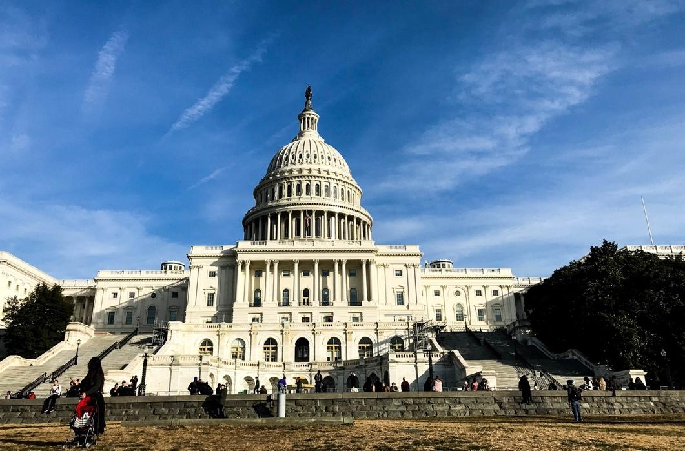

Each Congressional chamber has its individual powers and responsibilities as outlined by the Federal Constitution. A bill (proposed legislation) must pass both the House and the Senate and then be signed by the President to become a law.

The total voting membership within the Congress is 535 members (100 of this membership is made up of senators with two deriving from each of the 50 states). The remaining 435 members are representatives serving in the House elected from the states. There are also six non-voting members of the House of Representatives representing Washington DC, and each of the other U.S. territories or colonies, including: Puerto Rico, American Samoa, Guam, the Northern Mariana Islands and the U.S. Virgin Islands.

The House of Representatives

In Article I, Section 2 of the Constitution we learn the process for electing members to the House of Representatives (the Lower Chanber).
- You must be 25 years of age to serve in the House of Representatives and have been a citizen for at least seven years.
- One can only be elected to the House for a period of two years, which means that every two years representatives need to run for re-election. Every two years there is a new Congress based on this two-year term. The present Congress is the 116th Congress serving from 2019 to 2021. The 115th Congress lasted from 2017 to 2019 and the 114th Congress from 2015 to 2017.

Each state is given a number of congresspersons (representatives in the House) based on its respective population. The most populous states like California (with 53 representatives), Texas (with 34 representatives) and New York (with 27 representatives) have a large number of house members, while the states with the smallest populations, Alaska, Delaware, Montana, North Dakota, South Dakota, Vermont and Wyoming all only have one congressperson.

The House has a Speaker and other offices that it can choose and has the “Sole Power of Impeachment” meaning that the House can charge the President, as well as other federal officials, with impeachable offenses. Impeachment is akin to someone being charged with a crime. After the impeachment hearing (trial) where the senate acts as a jury, if the person is found “guilty” the result of being impeached is that the “impeached individual is removed from his or her position. The Speaker of the House is elected from the majority party in the House. Since Democrats took control of the House of Representatives in January 2019, Nancy Pelosi, a Democrat, has served as the Speaker of the House and is a democrat from California.

https://www.youtube.com/watch?v=A-4dIImaodQ

The districts that federal house members represent are generally drawn by State Legislatures. Since the 18th century legislators have often drawn congressional districts in a way that favors one political party over another in a process called Gerrymandering. In recent years this process of elected officials in essence choosing their voters has become more precise with improved technological tools. This process often leads to geographically awkward districts connected at times by a single road. In Maryland, Democrats have concentrated a Republican majority in a single district which allowed the other seven federal house seats to be easily won by Democrats. In a state where 1/3 of the population voted for a Republican Presidential candidate, just 1 in 8 house members will be a Republican. The 2014 North Carolina congressional map, drawn up by Republicans in the state legislature, made it so the state sent only three Democrats compared to ten Republicans to congress in a state that has nearly an equal number of voters in each party. You can see in the map below that the districts were drawn to group Democratic, and generally African American communities within the same few districts to limit their political influence over many congressional races. The remaining districts would thus be dominated by whiter and more Republican voters who could claim more seats.

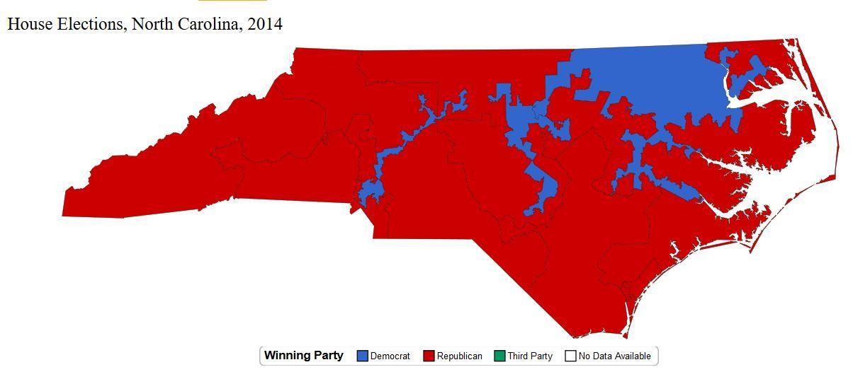

Assignment: Draft a letter (no longer than a page) to an elected official attempting to convince them to support a Constitutional amendment that would end the practice of Gerrymandering. Use evidence from the chapter and the video Gerrymandering: Last Week Tonight with John Oliver to support your request.

The Senate

The other part of the Congress is the Senate. The requirements to serve in the Senate (the Upper Chamber) are laid out in Article I, Section 3 of the U.S. Constitution.
- The age requirement to serve in the Senate is 30 years old, with service lasting for six years.
- To be a Senator one must have also been a citizen of the United States for at least nine years.
- Senators are elected every six years.

The Constitution states that there will be two senators from each state. Today there are 100 Senators, each elected to six-year terms. The population of a state does not matter in terms of representation in the Senate as with the House. This gives significantly more political influence to smaller and more rural states like South Dakota and Wyoming over larger more diverse states like New York and California. The 19,500,000 New Yorkers have the same number of senators as the 580,000 Wyomingites. As is the case in the House of Representatives, U.S. citizens living in U.S. territories are not represented by voting members in the Senate.

Assignment: In a paragraph answer the following prompt: Is the system of giving two senators to each state a good one? Why or why not?

The Senate Majority Leader is chosen from the senators in the majority party. With the Senate currently controlled by Republicans, the Majority Leader is Mitch McConnell from Kentucky. The Senate Minority Leader is chosen from the minority party in the Senate, at present the Democrats. The Democratic Senators chose Charles (Chuck) Schumer of New York as their leader. The Senate also chooses its own “Officers” and will elect from its ranks a “President Pro Tempore.” The President pro tempore is the fourth person in the order of succession to the Presidency.

The Powers of Congress

While the House can vote to impeach, the Senate has “the sole power to try all Impeachments.” This is akin to a trial where witnesses are called, evidence is introduced and the Chief Justice of the United States Supreme Court acts as the judge. After the trial, senators vote on whether the person should be impeached or not. Following an affirmative vote, the impeached person is removed from office. “Judgement in Case of impeachment shall not extend further than to removal from office, and disqualification to hold and enjoy any Office of honor, Trust or Profit…” The House has voted three times to impeach a sitting president; but at the senate trial, the Senators voted not to “impeach” (remove from office) the then president. As a result, Presidents Andrew Johnson (1865-1869), Bill Clinton (1993-2001) and Donald Trump (2017-2021) all remained in office. President Richard Nixon (1969-1973) was being tried and would likely have been impeached by the U.S. Senate, but he resigned before that could happen.

The Senate has the power to confirm Presidential appointees. This gives this body significant influence over the selection of federal judges and other executive officials including the Secretary of State and the CIA Director. Republicans were able to block Democratic President Barack Obama’s nominee Merrick Garland to the Supreme Court because they controlled the Senate during the final year of Obama’s administration.

In principle, Congress is empowered to declare war. However, as you will see in later chapters on U.S. Foreign Policy, the power to declare war has largely been abdicated to the executive branch. Despite participating in conflicts across the globe, the United States Congress has not officially declared war since World War II after the attack on Pearl Harbor.

Assignment: Write a paragraph explaining your position to the following prompt: Is it better for Congress to have the power to declare war as is written in the U.S. constitution, or for the President to make the decision to deploy U.S. forces abroad as has been the practice of the United States since World War II?

For anything to pass the U.S. Senate, historically Senators needed to muster a “Filibuster-proof” 60 of 100 votes in favor of a bill or an appointee. However, in the past decade both Republican and Democratic Senators have chipped away at that requirement. For the time being, 41 senators can still “Filibuster”, or stop most legislation, however that requirement has recently been replaced in favor of a simple majority for all Executive and Judicial appointees of the President.

The Powers of the Congress

What Congress Can Do.

Article I, Section 8 of the U.S. Constitution lists 18 enumerated powers of the Congress. This section in essence describes the “powers of the Congress,” more simply, what Congress can do.

Congress can:
- Collect Taxes
- Borrow Money
- Regulate Commerce (Business and Trade)
- Establish Rules of Naturalization (Make Immigration Policy)
- Coin Money (Make Money)
- Punish Counterfeiters
- Establish Post Offices
- Promote the Arts and Sciences
- Create Tribunals Inferior to the Supreme Court
- Declare War
- Raise and Fund Armies
- Provide and Maintain a Navy
- Make Rules for the Governing of a Navy
- Suppress Insurrections (Rebellions)
- Make Rules for The Land and Naval Forces
- Discipline the Militia
- Govern Washington D.C.
- Make All Laws Which Shall be Necessary and Proper

What the Congress Cannot Do.

With a broad range of power in the hands of Congress, it is important to know that there are designated actions that the Congress cannot undertake. These are enumerated in Article I, Section 9 of the U.S. Constitution. For instance, until 1808, Congress could not stop the importation of Enslaved Africans. This is just one of several sections where the U.S. Constitution discusses slavery, without directly talking about the ethics, economics or violence of the slave trade. Written in 1787 and adopted in 1789 the Federal Constitution sanctioned the importation of enslaved persons until the beginning of the 19th Century, challenging the idea that the United States was founded to preserve Freedom and Liberty for all. As revolutionary a statement as this may be, the U.S. Constitution allowed “human trafficking”, slavery by another name.

Congress is also prevented from suspending the “Writ of Habeas Corpus.” Congress cannot pass “Bills of Attainder” or created “Ex Post facto Laws.” The Congress is also prohibited from granting “Title(s) of Nobility.” The primary function of Habeas Corpus is to release someone from unlawful imprisonment. If someone is in custody of law enforcement unjustly, a lawyer may appear before a federal judge to secure an order (writ) that would challenge the unjust confinement. A Bill of Attainder is any legislation (law) that punishes a group without a hearing or trial. An Ex Post Facto law is a law which provides for the infliction of punishment upon a person for an act done which, when it was committed, was not a crime. Thus, if a person committed a particular act that was not a crime at the time, but that act later became criminalized by the creation of a “new” law, the person who committed that act previous to the new law cannot be punished.

Assignment: In a paragraph write why you think the authors of the Constitution thought it was important to limit the power of a congress to suspend Habeas Corpus, pass a Bill of Attainder or create Ex Post Facto Laws.

Congressional Committees

Congressional work is organized through committees: “Standing Committees” which continue over time, “Special Committees” and “Select Committees” that emerge in response to emergent concerns. Standing Committees prevail over time, extending from one Congress to the next Congress with fixed jurisdictions and stable memberships. Currently there are 20 standing committees in the House and 16 in the Senate including: the Judiciary Committee, the Armed Services Committee and the Budget Committee.

Special Committees and Select Committees are appointed specifically to deal with an emergent problem.

Special and Select Committees often reflect the politics and priorities of a particular party. When Republicans controlled the House in 2014 they formed a “Select Committee” to investigate the actions of the Democratic Obama Administration during the uprising in Benghazi, Libya where the U.S. consulate was attacked and the U.S. ambassador was killed. A “Special Committee” was established by Democrats on Energy Independence and Global Warming in 2007, and then disbanded when Republicans took control in 2011. In 2019, when Democrats regained control of the House, they established a new Select Committee on the Climate Crisis.

How a Bill Becomes a Law

https://www.youtube.com/watch?v=FFroMQlKiag

The Senate

A “bill” is drafted (written) by a senator and introduced into the Senate. When the bill is introduced into the Senate it is referred to a committee. The senate committee convenes hearings on the bill and the bill is “marked up.” Eventually the bill is introduced to the senate floor where it is debated and voted upon. The bill is then referred to the “Conference Committee” to be reconciled with prior relevant legislations that may have been introduced in the House. If there is agreement between the House and the Senate on this bill, it is then presented to the President for the Presidential signature. (Karnell, 2020)

The House

A bill is introduced into the House by a specific congressman or congresswoman (Congressperson) and referred to a committee or committees for hearing, or markups, and reported out. The “rules committee” determines specific rules regarding how the bill will be debated. The bill then moves to the House floor for debate. (Karnell, 2020)

Shaping Legislation

After being debated, the bill moves to the “Conference Committee” to be reconciled with a submitted Senate bill. After a bill is ironed out in conference, it is returned for a vote in both the Senate and the House. Passage will then lead to the bill being presented to the President for signature. As with any bill presented to the President, the President can veto the bill and send it back to Congress where a vote by two-thirds of each house of Congress will be required to override the President’s veto. Because it’s so difficult to override a Presidential Veto, congress will often negotiate with the President when crafting legislation. In December of 2020 the congress moved to override President Trump’s veto of the defense bill. The Congress also overrode President Obama’s veto.

https://www.youtube.com/watch?v=STZMtio7KqU

In many instances various interest groups and lobbyists—people paid to influence legislation—may ask specific members of congress to introduce bills, or amendments to bills. By financially supporting legislators’ reelection campaigns, lobbyists and their financial backers can often influence legislation to be more favorable to their interests. Because members of congress have to run for reelection every two (House) or six (Senate) years, and because elections are extremely expensive, most members of congress have become dependent on wealthy campaign contributors and special interests. With weakened campaign finance laws since the Supreme Court ruling Citizens United v. Federal Election Commission (2010), the economic elite have gained increased sway over the laws passed, or not passed, by Congress and signed by the President. For instance, while a public survey showed that in October 2020 69% of voters supported free public health care, the heads of both major political parties do not. The powerful private health care industry has ensured that the leadership within the Democratic and Republican parties are against Medicare for All. (“Poll: 69 Percent of Voters Support Medicare for All”)

Assignment: After watching “The Truth About Citizen United” and reading “Shaping Legislation,” write a paragraph explaining why unlimited money in politics can be problematic. Please focus on a specific issue where money can influence laws passed.

Summary

Article One of the U.S. Constitution established what was supposed to be the most important branch of government, the Legislative Branch. Congress is organized into the House and Senate. In both congressional chambers, legislators legislate. They are empowered to impeach the President and other government officials, control the budget and declare War, although not recently.

The bicameral system’s foundations and functions have resulted in unequal representation in Congress, where citizens in less populated states have more political power than citizens in more populated states. Voters in large and small states are significantly more politically influential than U.S. citizens and U.S. nationals residing in U.S. territories or Washington D.C. Further, the process of electing members of Congress is often structured in ways that prevent the majority from exerting its will. This has profound implications for the policies pursued by the U.S. government as some states and demographics are better represented than others. Finally, legislators have become increasingly beholden to special interests and wealthy campaign contributors to fund their reelection campaigns, significantly influencing the laws passed and not passed by congress.

Assignments

- Draft a letter (no longer than a page) to an elected official attempting to convince them to support a bill that would end the practice of Gerrymandering. Use evidence from the textbook and the video to support your request.
- In a paragraph answer the following prompt: Is the system of giving two senators to each state a good one? Why or why not?
- Write a paragraph explaining your position on the following prompt: Is it better for Congress to have the power to declare war as is written in the U.S. constitution, or for the President to make the decision to deploy U.S. forces abroad as has been the practice of the United States since World War II?
- In a paragraph write why you think the authors of the Constitution thought it was important to limit the power of a congress to suspend Habeas Corpus, pass a Bill of Attainder or create Ex Post Facto Laws.
- After watching “The Truth About Citizen United” and reading “Shaping Legislation,” write a paragraph explaining why unlimited money in politics can be problematic. Please focus on a specific issue where money can influence laws passed.

Key Terms

House of Representatives
Senate
Bi-Cameral Legislature
Constitutional Conversion of 1787
The Great Compromise
Gerrymandering
Habeas Corpus
Ex Post Facto Laws
Bill of Attainder
Congressional Committees

References

Poll: 69 Percent of Voters Support Medicare for All

Jordan, T. (2019). The U.S. Constitution And Fascinating Facts About It. Napervill: Oak Hill Publishing Company.

Kernell, S., Jacobson, G., Kousser, T. & Vavreck, L. (2020). The Logic of American Politics. Thousand Oaks, CA: Sage.

The House is referred to as the “Lower Chamber.” The Senate is considered the “Upper Chamber.”
Habeas Corpus is Latin for “you have the body”. An independent [court] proceeding is instituted to determine whether a defendant is being unlawfully deprived of their liberty. Initially the writ only permitted a prisoner to challenge a state conviction on constitutional grounds that related to the jurisdiction of the state court. The writ (order) now extends to all constitutional challenges.

